AKS Kubernetes Cluster to Jenkins instance to run builds
CMSUPPORT-138475

- Prerequisites for creating AKS nodes in Jenkins:
    - Kubernetes cloud name
    - Kubernetes URL
    - Kubernetes server certificate key
    - Kubernetes Namespace
    - Service account
    - Service account token
    - Jenkins instance
All these information to be provided by the user.

Kubernetes – Cluster Dashboard (where API address can be procured)
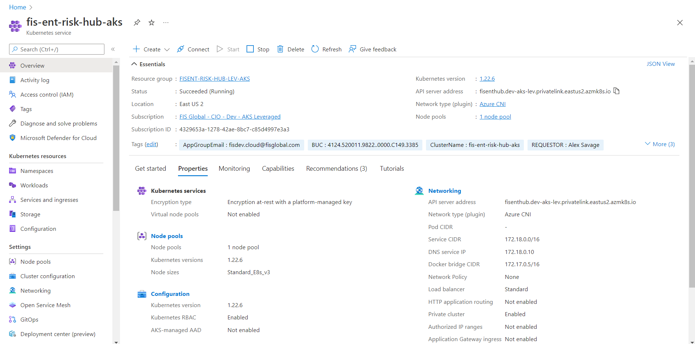

- Go to the mentioned Jenkins instance. On the left column select “Manage Jenkins”. Scroll down and select “Manage Nodes and Clouds” under system configuration.
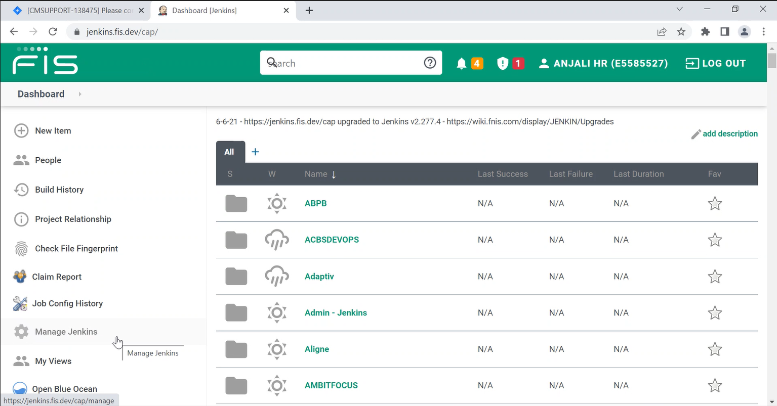

- Select configure clouds.
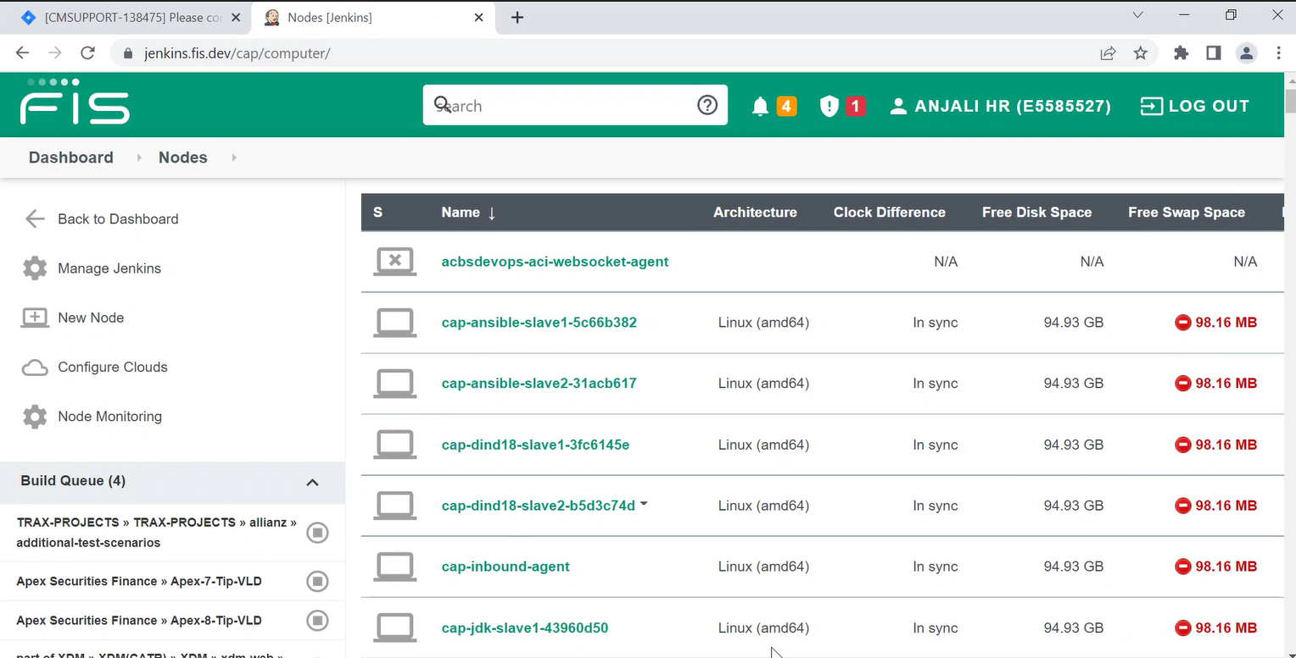

- Go to the bottom of the page and add a new cloud – Kubernetes.
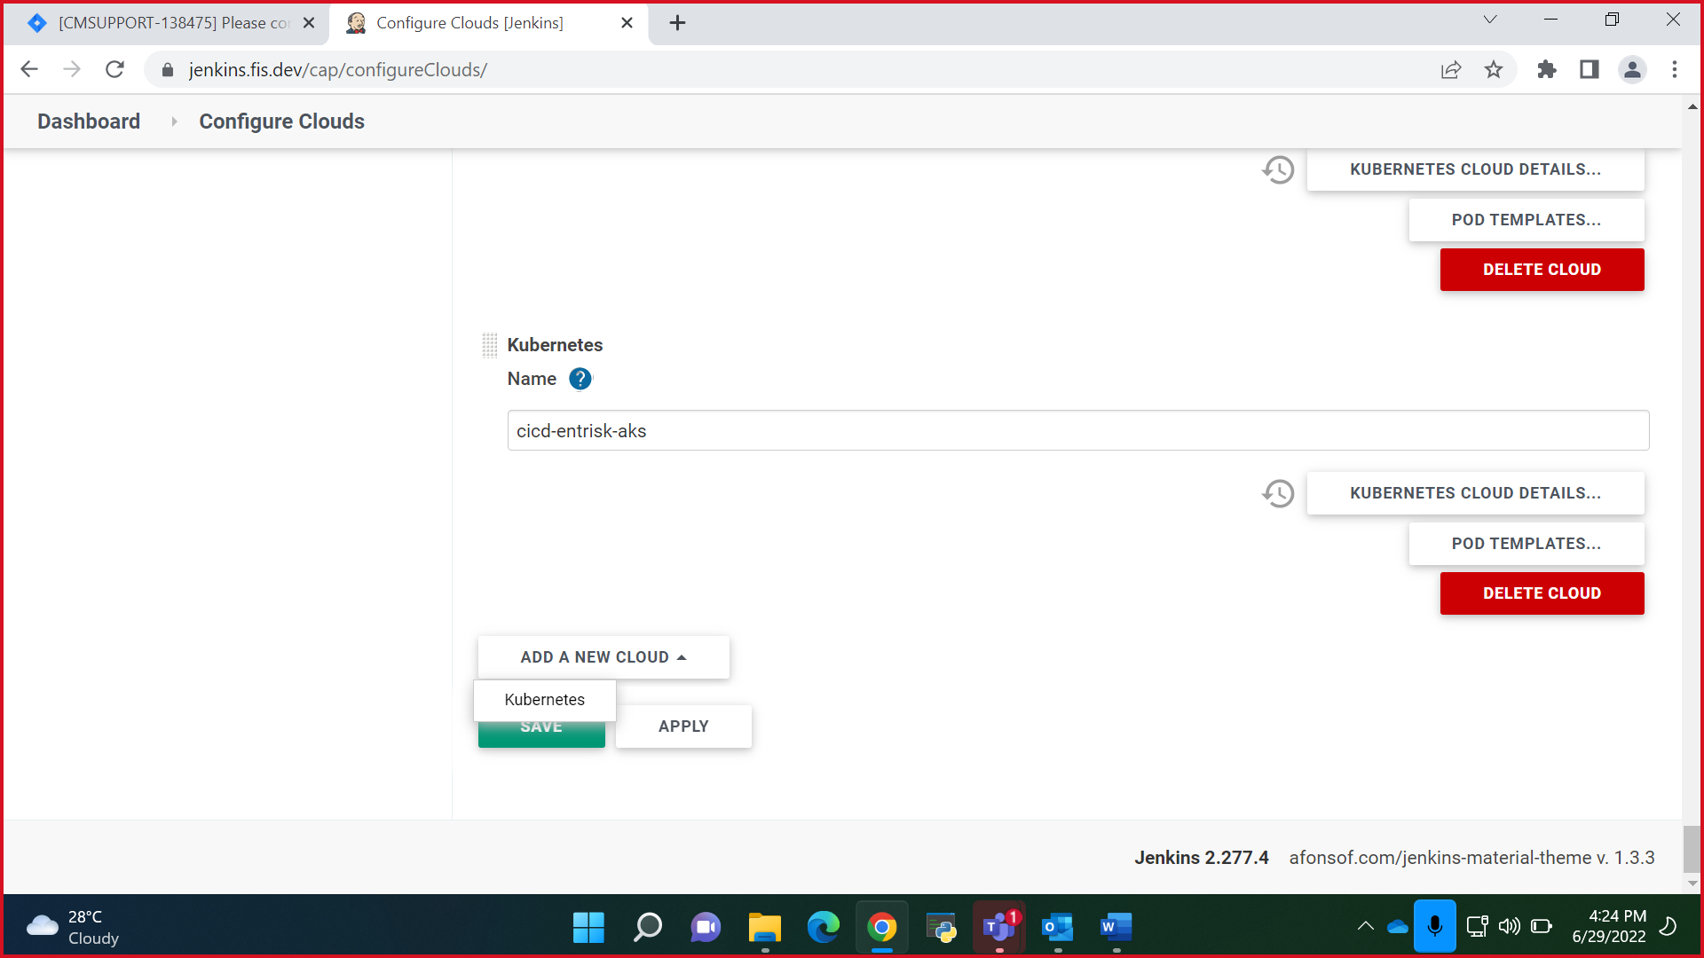

- Click on Kubernetes cloud details and add all the information in it provided by the user.
  - Kubernetes cloud name: cicd-entrisk-aks
  - Kubernetes URL: https://fisenthub.dev-aks-lev.privatelink.eastus2.azmk8s.io:443
  - Kubernetes server certificate key: Can be provided
  - Kubernetes Namespace: devops-tools
  - Service account: jenkins-admin
  - Service account token: to be provided via mail by the user
  - Jenkins instance: https://jenkins.fis.dev/cap/job/adp/
Once credentials is added, click on test connection. If the connection is successful, the pipeline is successfully created. Ensure to click on “disable https certificate” as shown in the screenshot.
NOTE: Jenkins Tunnel information can be got from the previous pods in the instance. No other modification needs to be done in the pod unless mentioned specifically.
NOTE: Credentials needs to be added in the Jenkins tool before creating the Pod. Process is mentioned below in point 6.
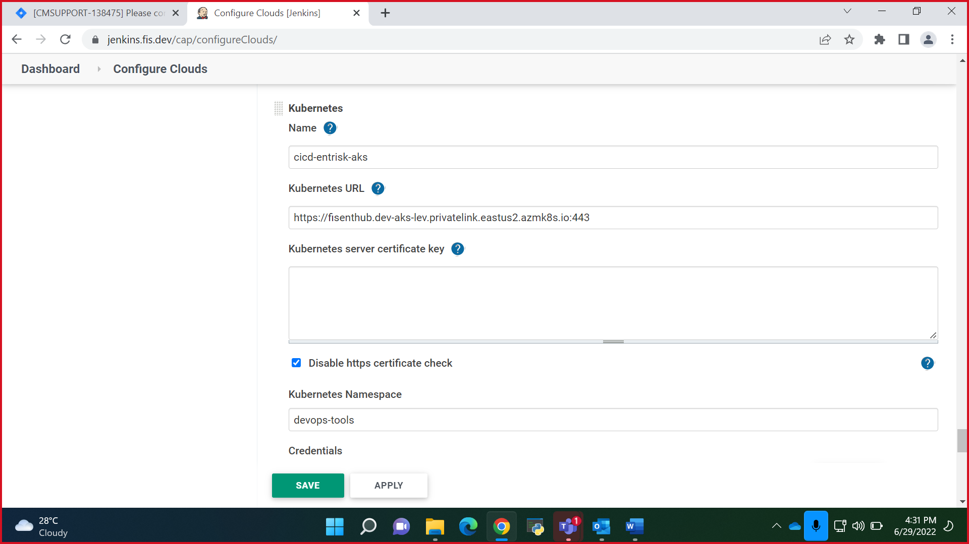
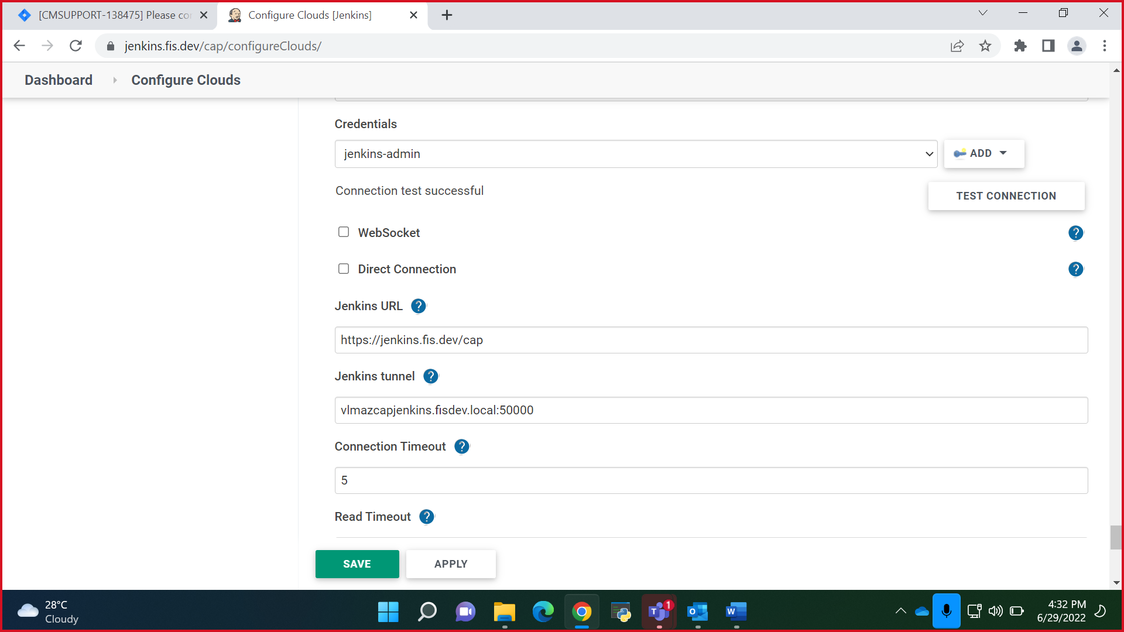

- Adding credentials in the Jenkins instance.
From Dashboard Manage Jenkins Manage credentials Global domain add credentials
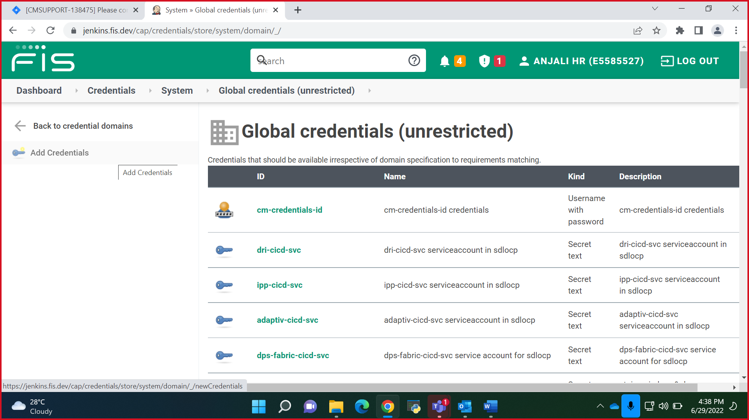

- Kind: Secret text
- Scope: Global (Jenkins, nodes, items, all child items, etc)
- Secret: should be the token that user shares.
- ID: Service account name
- Description: Service account name
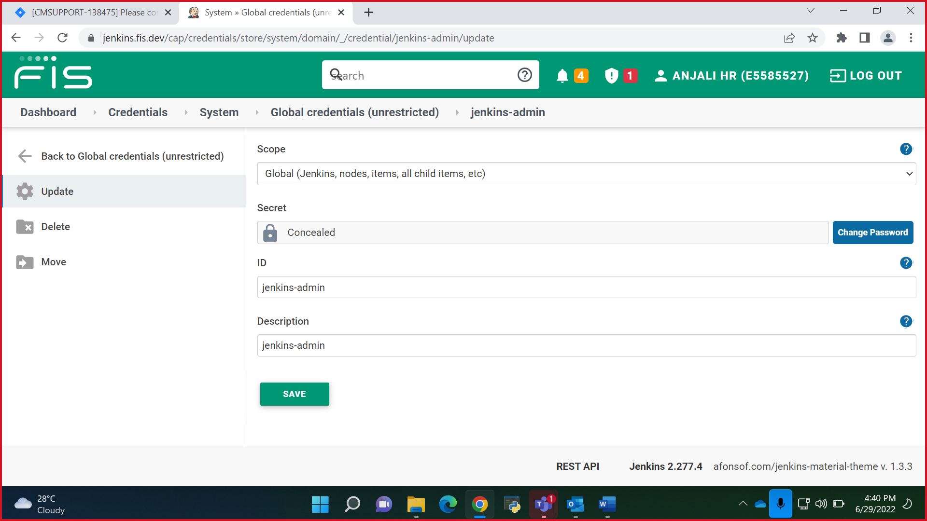

Suppose if you encounter these errors
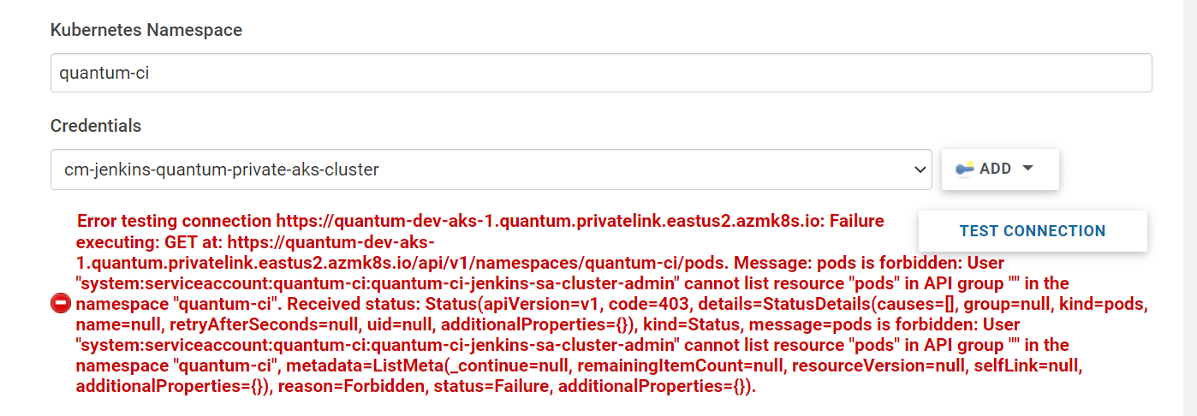
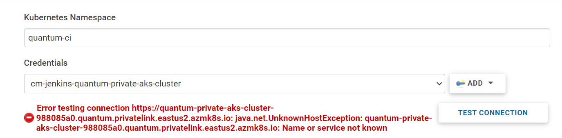

Ask user to run this command in user side to check permission issues
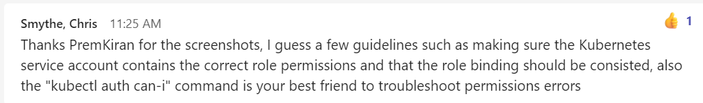
Kubectl auth can-i get pods

